HOW TO: Create a Non-Payroll Company
& Link the Org Hierarchy
Colleges & Halls — PeopleXD UOXU (Company 90)

System | PeopleXD (UOXU)
Topic | System Admin
Status | DRAFT — live UOXU screenshots embedded; pending screenshots noted
Version | 1.0 — 15 June 2026
Source | PeopleXD configuration session, 12 June 2026 (Conor, The Access Group)
Business Owner | Marie Cooksey, Head of HR Systems

Purpose
This guide explains how to set up a new non-payroll organisation structure in PeopleXD for a population that needs HR management (posts, appointments, hierarchy) but is not processed through payroll. Written for Colleges & Halls (Company 90) — steps apply to any non-payroll company.

Prerequisites
- Payroll Administration access in PeopleXD
- HR Administration access in PeopleXD
- Agreed company code, hierarchy codes and naming conventions confirmed
- Department records already exist in the system

Step 1 — Create the Non-Payroll Company
Navigation: Payroll Dashboard → Settings → Organisations

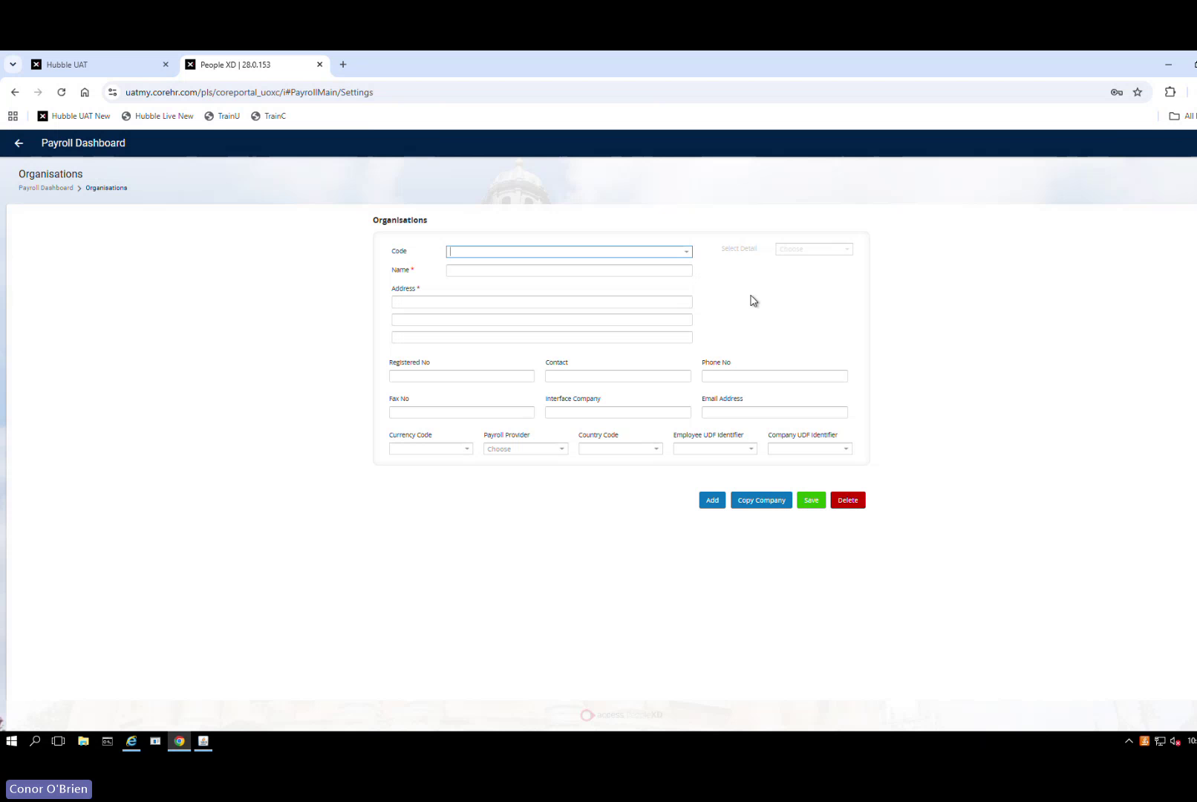
Organisations screen — Payroll Dashboard → Settings → Organisations
- Select Copy Company
- Choose the source company — Colleges and Halls
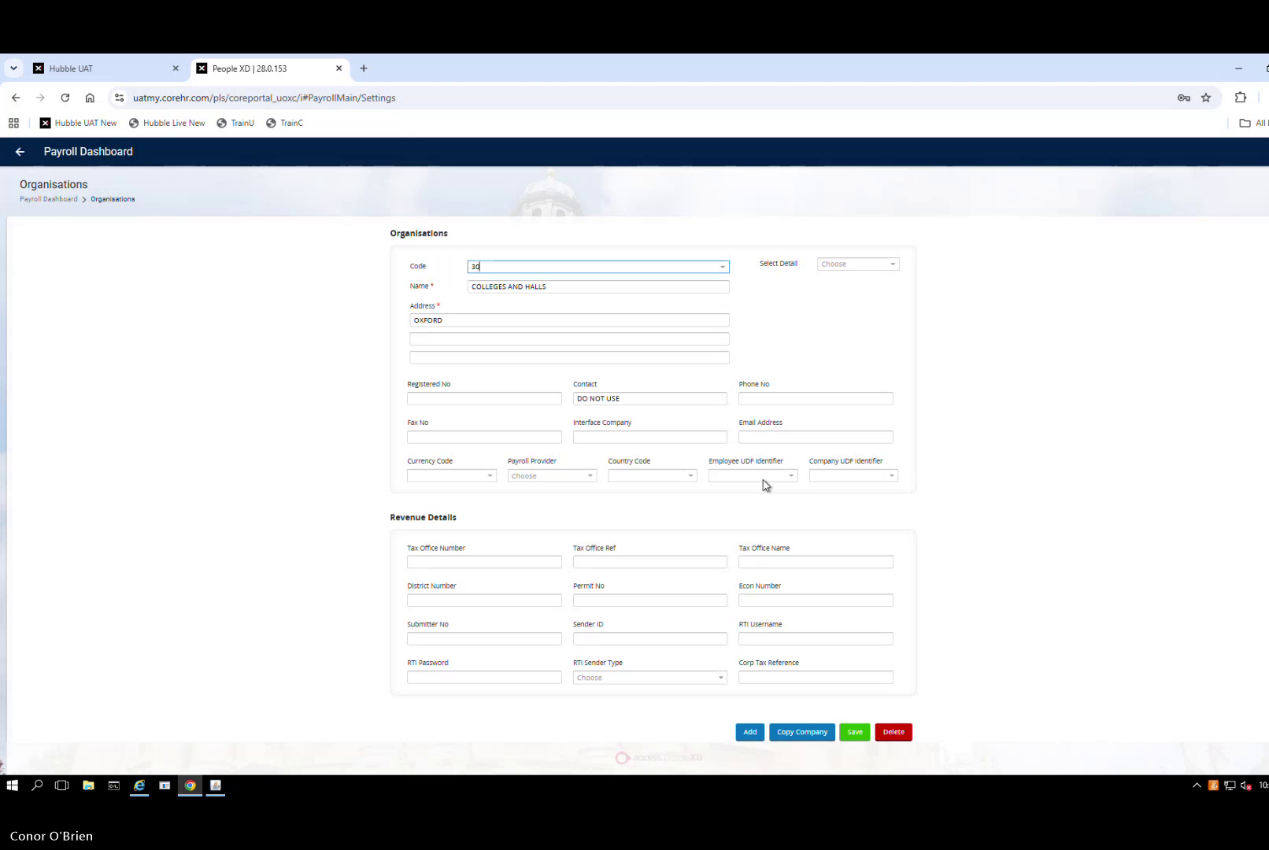
Source company — Colleges and Halls selected as the template to copy from
- Enter new company code: 90
- Rename the organisation: Non Payroll COLLEGES AND HALLS
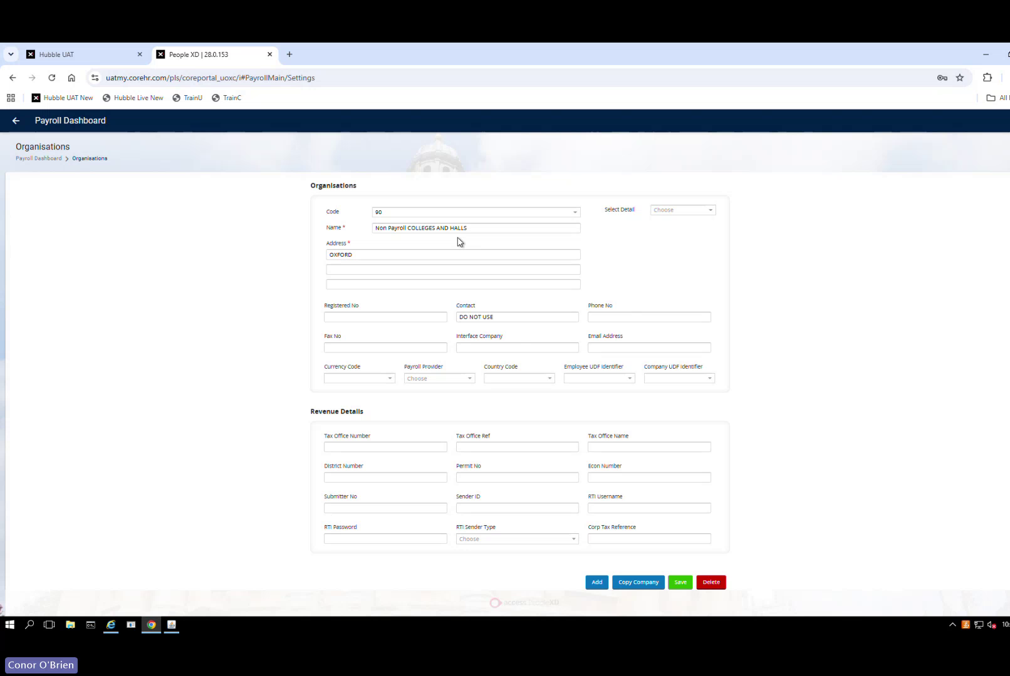
Company 90 — code and name entered before saving
- In the Contact field enter: REF2029 (internal reference)
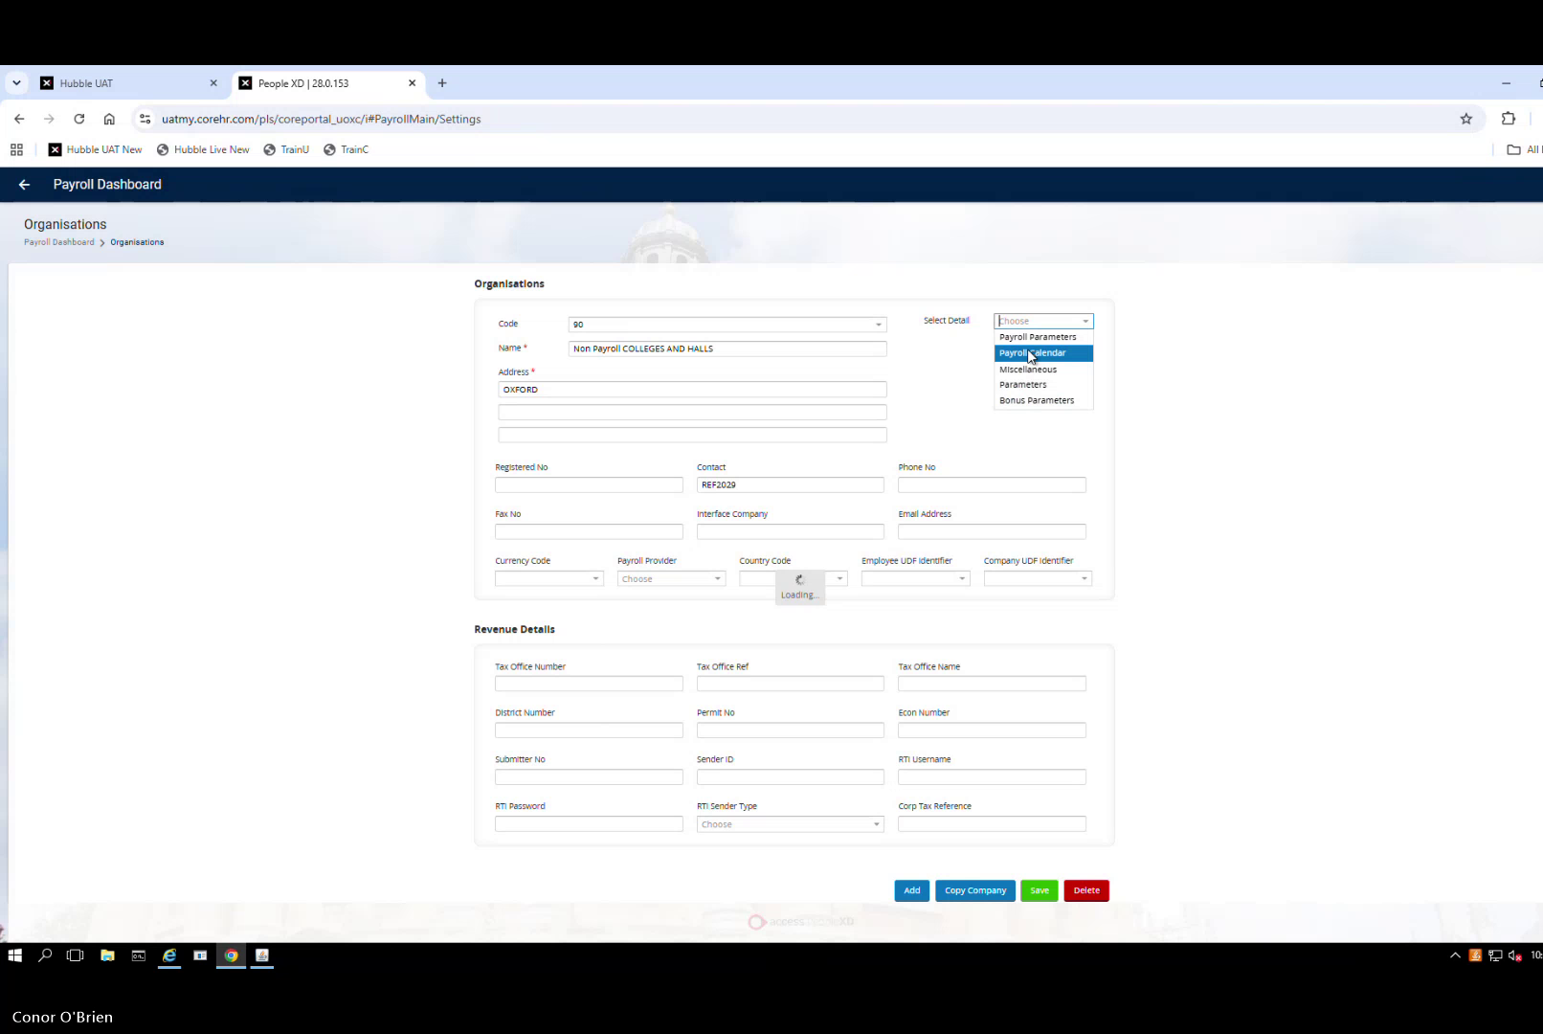
Company 90 completed — Contact = REF2029, ready to review sections
- Select Detail → review each section tab (Payroll Parameters, Payroll Calendar, Miscellaneous Parameters, Bonus Parameters)
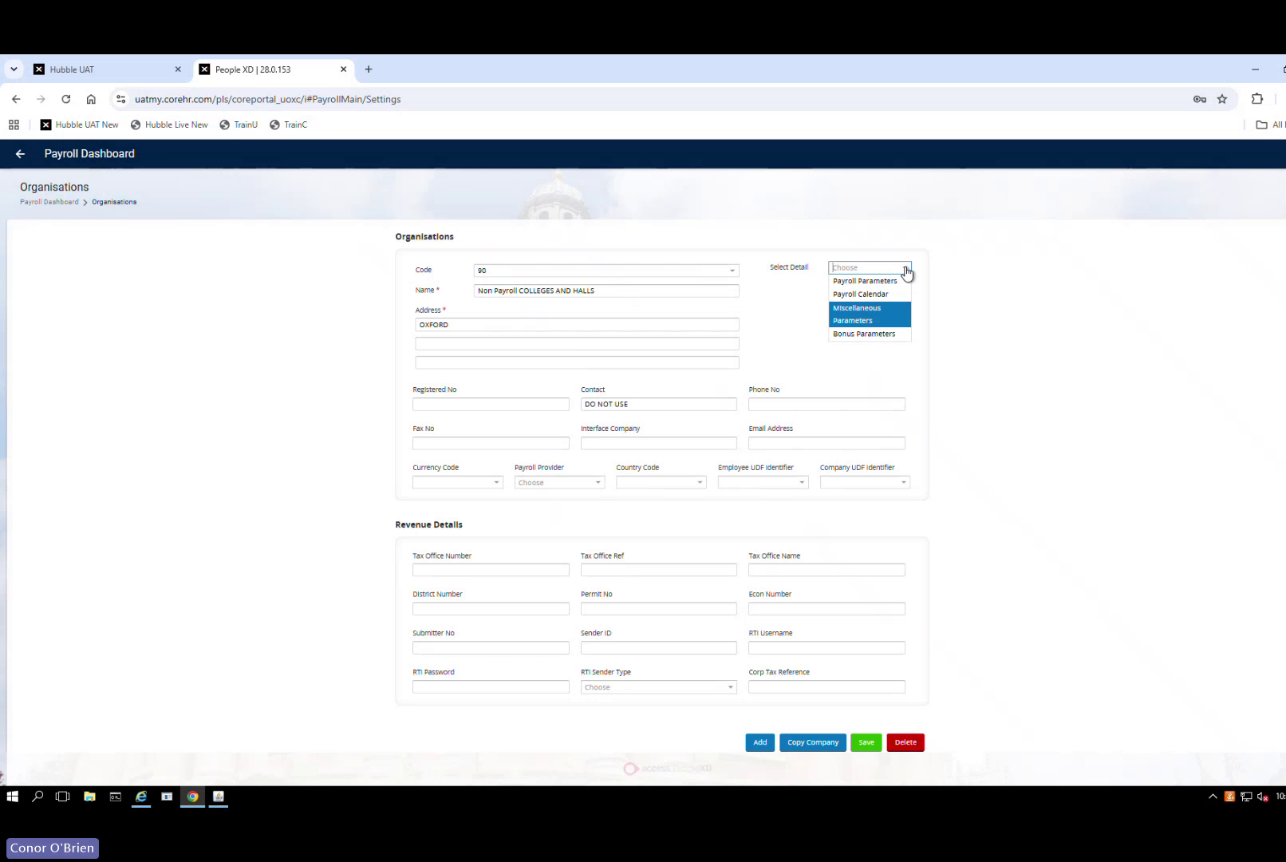
Reviewing copied sections — Payroll Calendar highlighted; remove or clear any payroll-specific values not applicable to a non-payroll company
- Remove all payroll-specific fields — revenue details, tax registration fields (Revenue Details section)
- Leave payroll registration fields blank — this company will not run payroll; no calendar link needed. System may warn about missing calendar — expected and acceptable
- Save
Note: If this company needs to become a registered payroll company in future, return and populate the tax, calendar and revenue fields at that point.
✓ Validate: Code 90 · Name = Non Payroll COLLEGES AND HALLS · Contact = REF2029 · No payroll registration details · Saves successfully

Step 2 — Create the Non-Payroll Pay Group
Navigation: Payroll Dashboard → Settings → Pay Groups

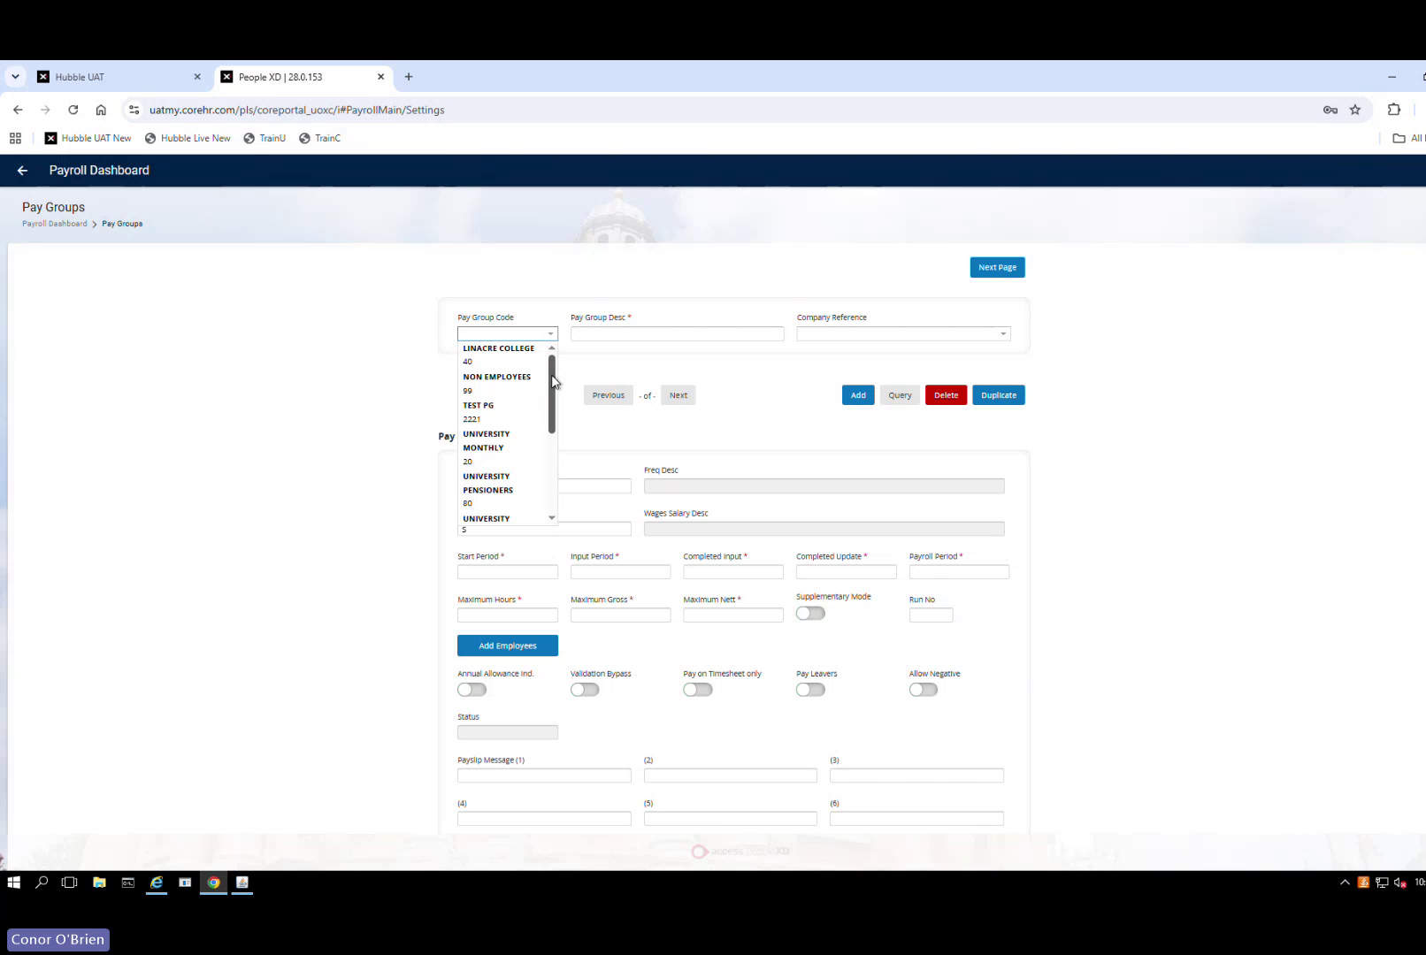
Pay Groups list — existing pay groups shown in dropdown; Non Employees is the source to duplicate
- Locate the existing Non Employees pay group
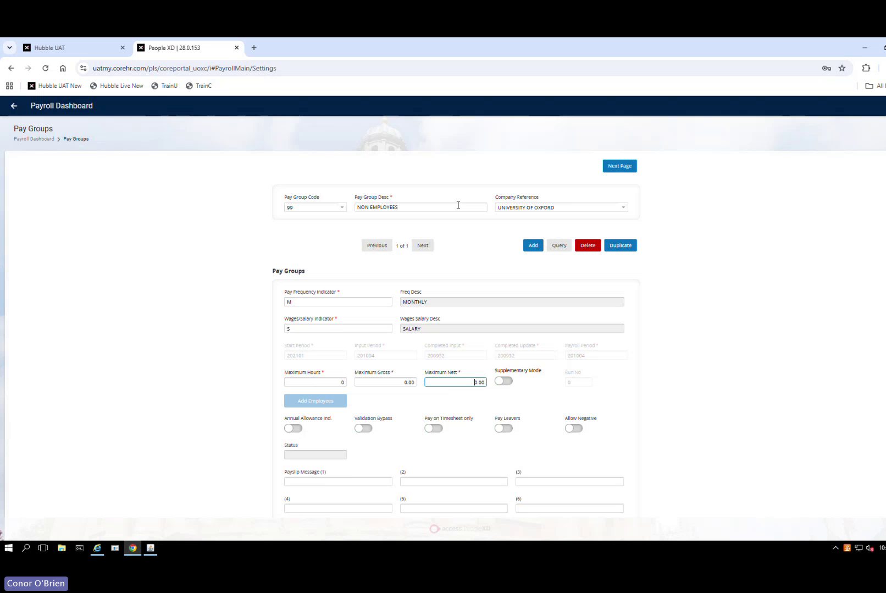
Non Employees pay group (code 00) selected — note the University of Oxford company reference
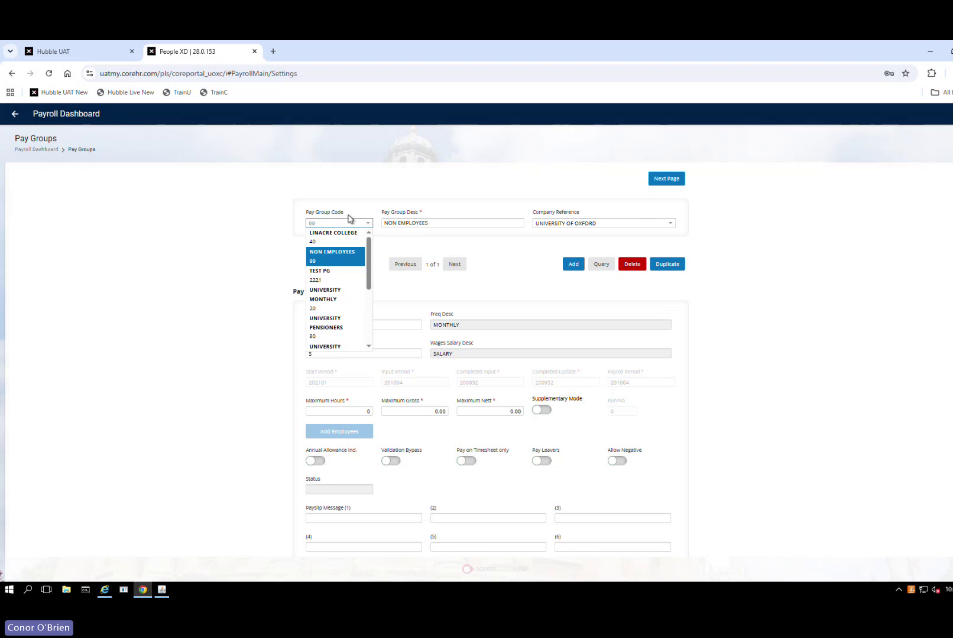
Selecting Non Employees from the dropdown as the source for duplication
- Select Duplicate
- Change Pay Group Code to: 90
- Change Pay Group Name to: ZZ Do Not Use College Non-Pay (ZZ prefix keeps it at the bottom of all lists — reduces risk of accidental assignment to a real employee)
- Link to Company 90 in the Company Reference field
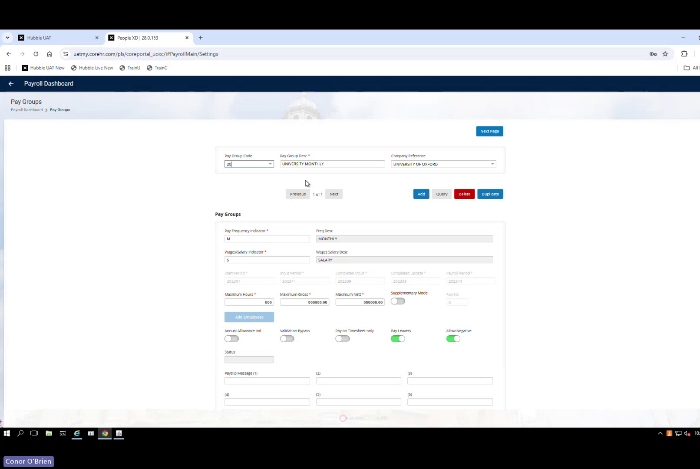
Duplicate pay group form — Pay Group 90 being configured with University Monthly copied settings; update code, name and company reference
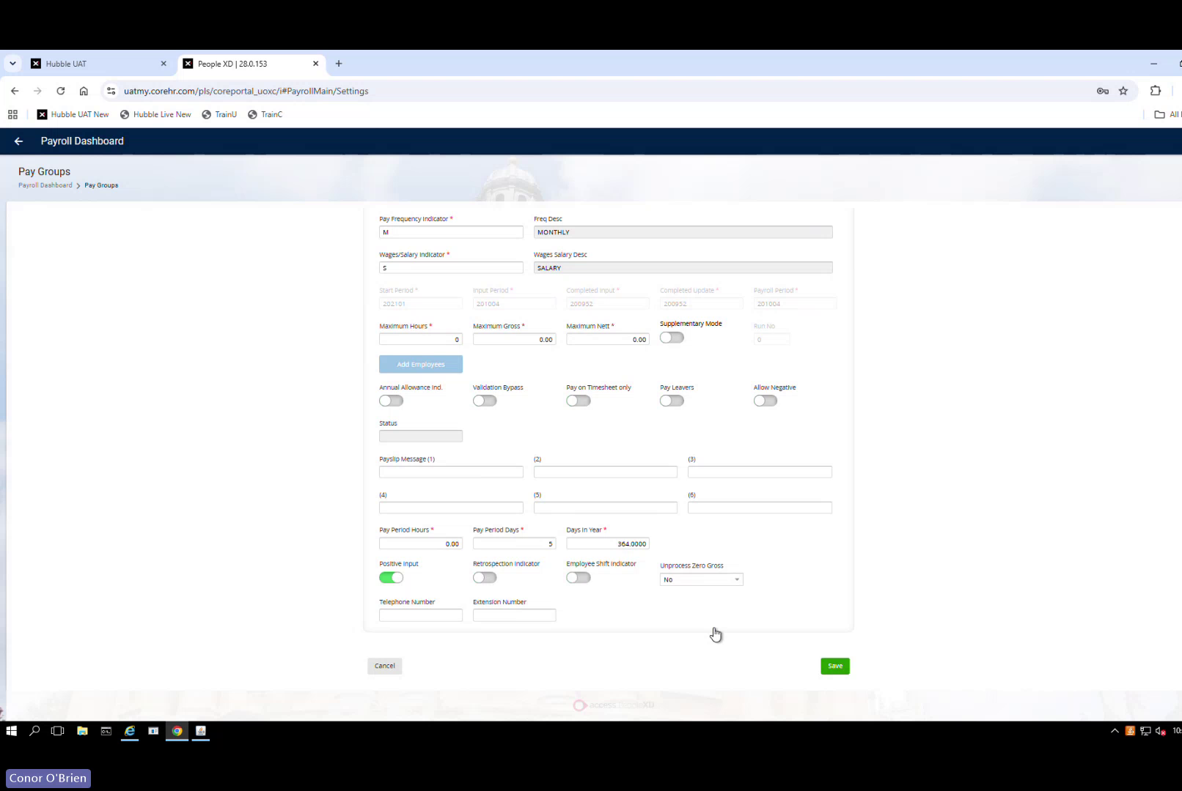
Bottom of the pay group form — review fields and Save
- Save
Known issue: Pay Group 90 failed to appear after creation during the 12 June session. This is a system issue — contact The Access Group via PXD Portal. Do not attempt to diagnose yourself. Do not delete the pay group if any staff have already been assigned to it.
✓ Validate: Pay Group Code = 90 · Linked to Company 90 · Appears in managed payroll list

Step 3 — Grant Pay Group Access
Navigation: Payroll Dashboard → Pay Group Access

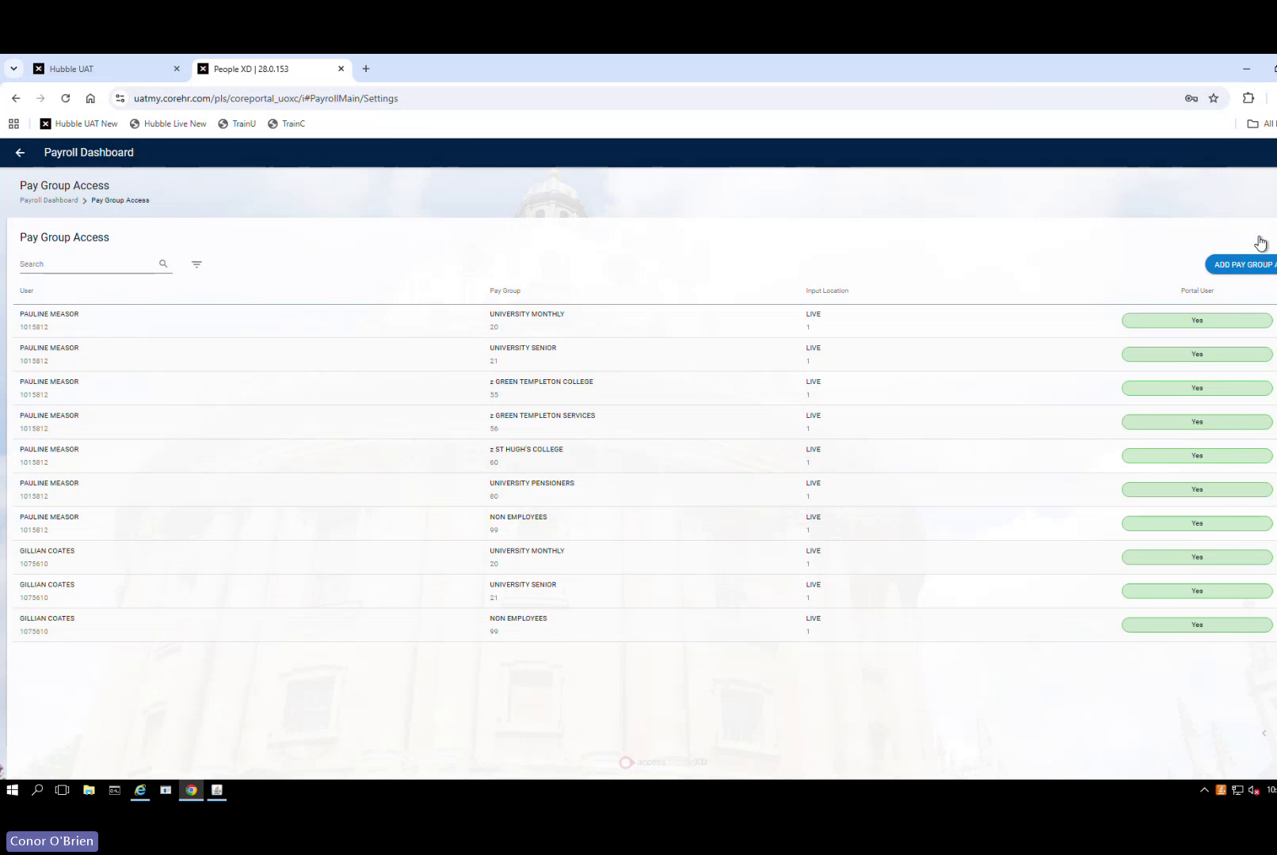
Pay Group Access — existing user/pay group access list; use Add Pay Group to grant access to Pay Group 90
- Select Add Pay Group (top right)
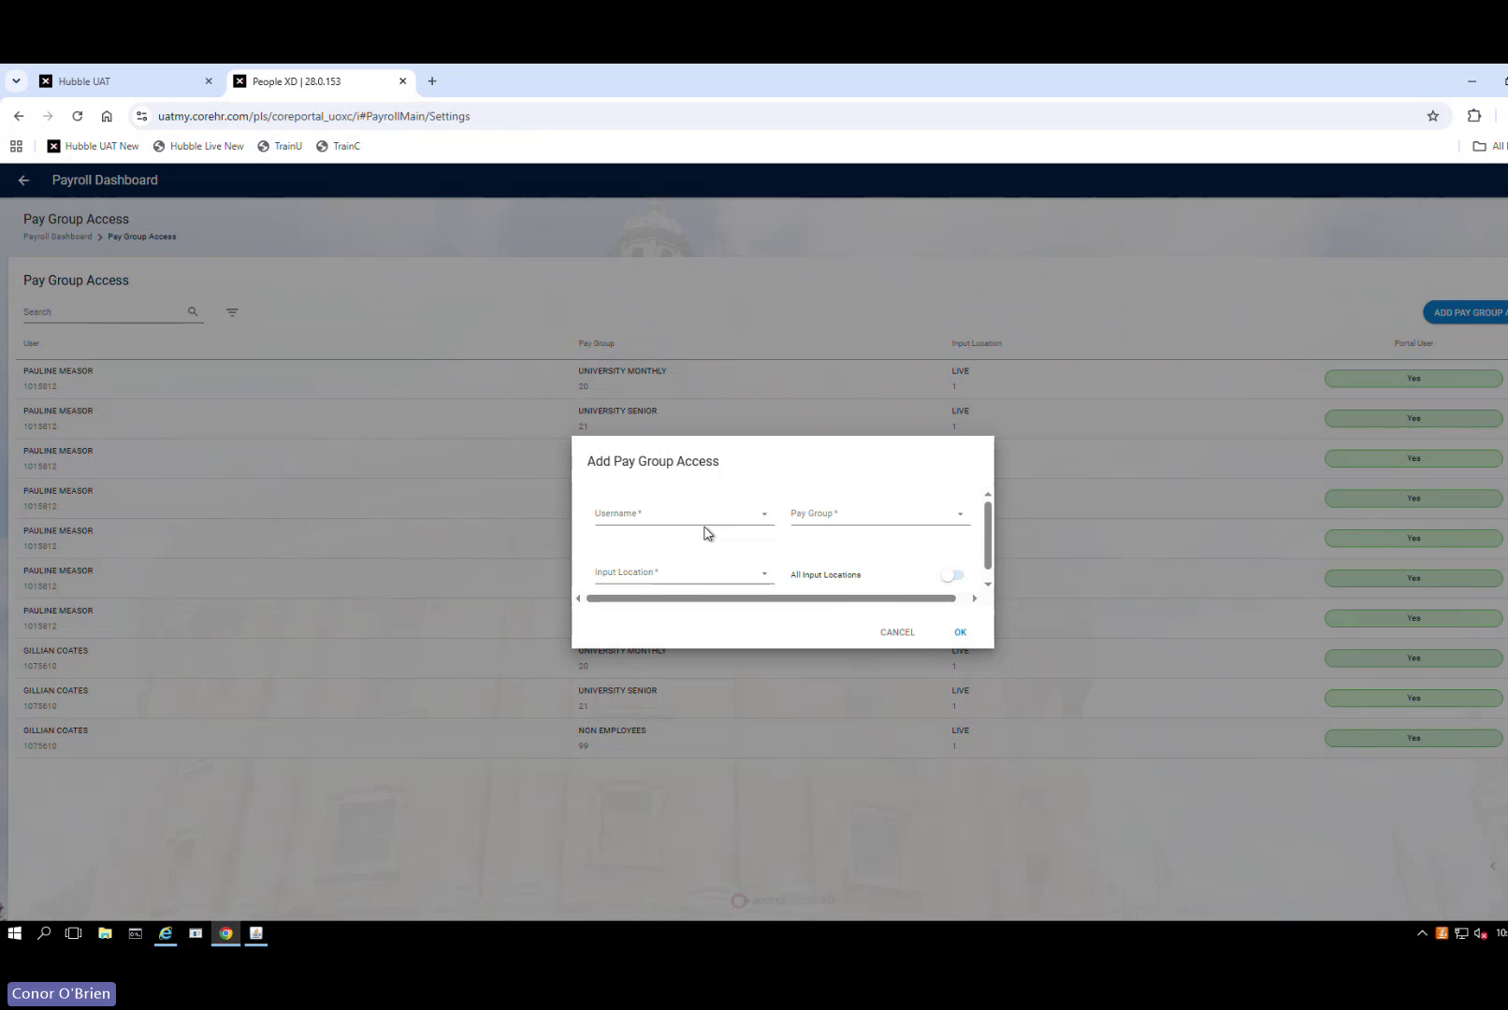
Add Pay Group Access dialog — enter username, select Pay Group 90, set All Input Locations
- Enter the username of each user who needs visibility of Colleges & Halls salary data
- Select Pay Group: 90 — ZZ Do Not Use College Non-Pay
- Input Location: All Input Locations
- Click OK
- Repeat for all relevant users
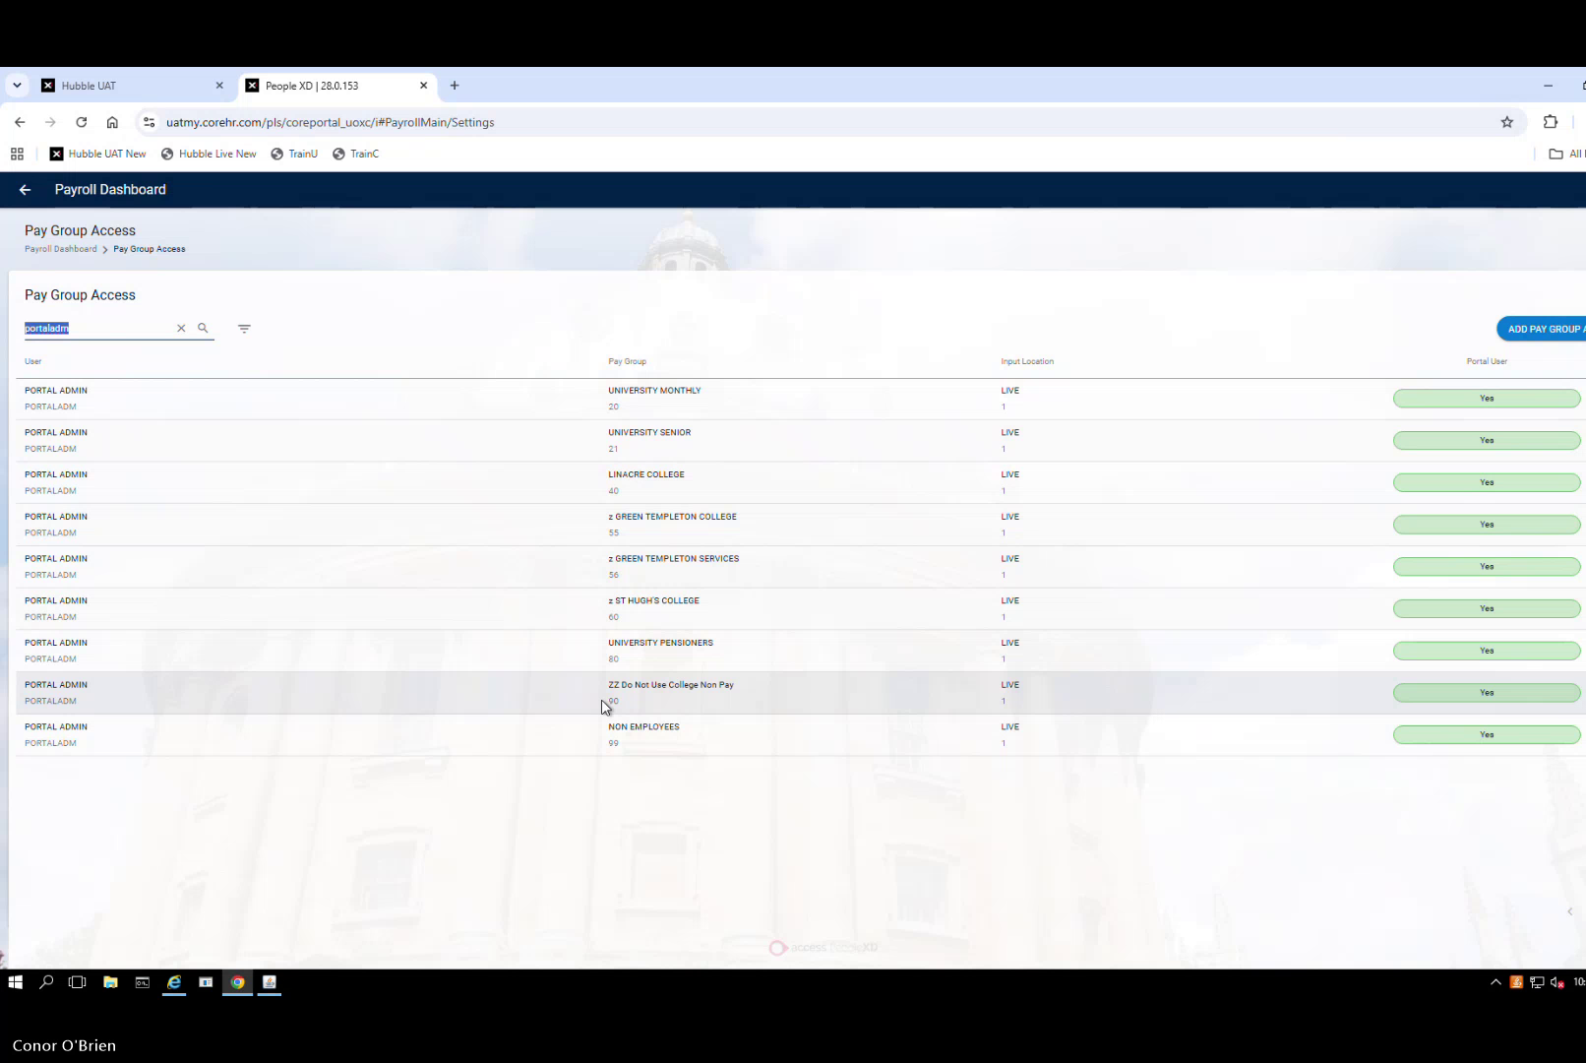
Pay Group Access list filtered to confirm — ZZ Do Not Use College Non-Pay (Pay Group 90) showing for Portal Admin
Critical: Without Pay Group 90 access a user CANNOT see the salary tab for any Colleges & Halls staff — even with full company-level HR access. Company access alone is not sufficient.
✓ Validate: Pay Group 90 in each relevant user's access list · Salary tab visible on a test Colleges & Halls staff record

Step 4 — Add Company to Data Centre
Navigation: Data Centre → search Company → Company Settings

- Add Company 90 to the company list
- Complete fields (name, RSI title) consistent with existing companies
- Save
Critical: Without this step users lose visibility of posts and appointments under Company 90 even after Pay Group access is granted. Both steps 3 and 4 are required.
✓ Validate: Company 90 appears in Company Settings list · Relevant users can see posts and appointments

Step 5 — Create the Hierarchy Reference Data
All navigation is via Reference Data in system settings. Create each level in order before moving to the next.

5.1 Division
Field | Value
Code | 901
Description | Colleges and Halls
Company | 90
Staff Requests | Leave inactive — not required for this company

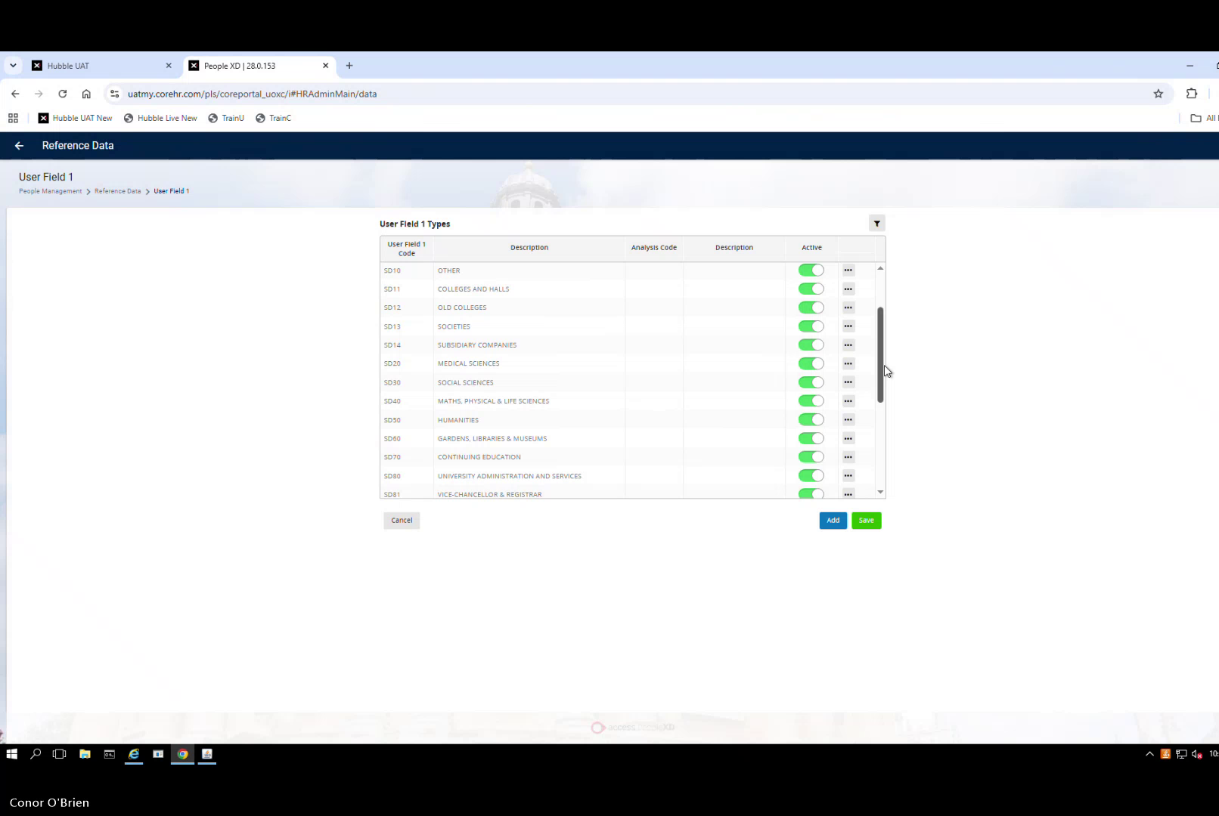
Reference Data → User Field 1 Types — Division codes. S011 = Colleges and Halls shown as an example of how Division codes appear in the system
✓ Validate: Division 901 appears against Company 90

5.2 Subdivision (USER_CODE1)
Field | Value
Code | ZSD901
Description | Colleges and Halls
Active | Yes

Screenshot pending: Subdivision ZSD901 in PeopleXD reference data — capture during live UOXU configuration

5.3 Level 4 (USER_CODE2)
Field | Value
Code | Z90101
Description | Colleges and Halls
Active | Yes

Screenshot pending: Level 4 Z90101 in PeopleXD reference data — capture during live UOXU configuration

5.4 Management Units
Create two entries:
Code | Description | Active
Z901 | Colleges & Halls | Yes
Z902 | Permanent Private Halls | Yes

Screenshot pending: Management Units Z901 and Z902 in PeopleXD reference data — capture during live UOXU configuration

Step 6 — Load Pay Administered By Reference Data
Use the Data Migration tool to load all 40 college codes at once rather than entering them individually.
Navigation: Data Migration → Templates

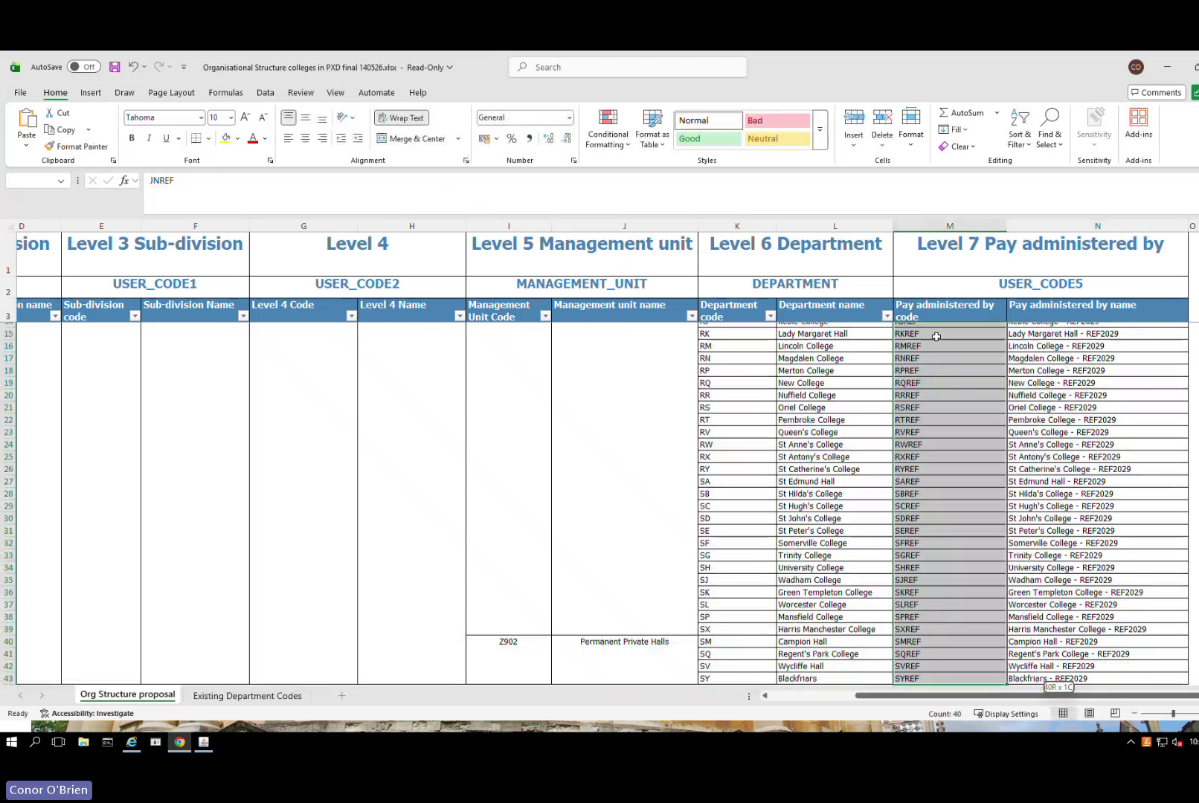
The hierarchy mapping spreadsheet — shows all levels (Subdivision, Level 4, Management Unit, Department, Pay Administered By). Use this as your reference when building the structure in Step 7B
- Download the HR Reference template and the Helper file from Data Migration → Templates
- Open the HR Reference template
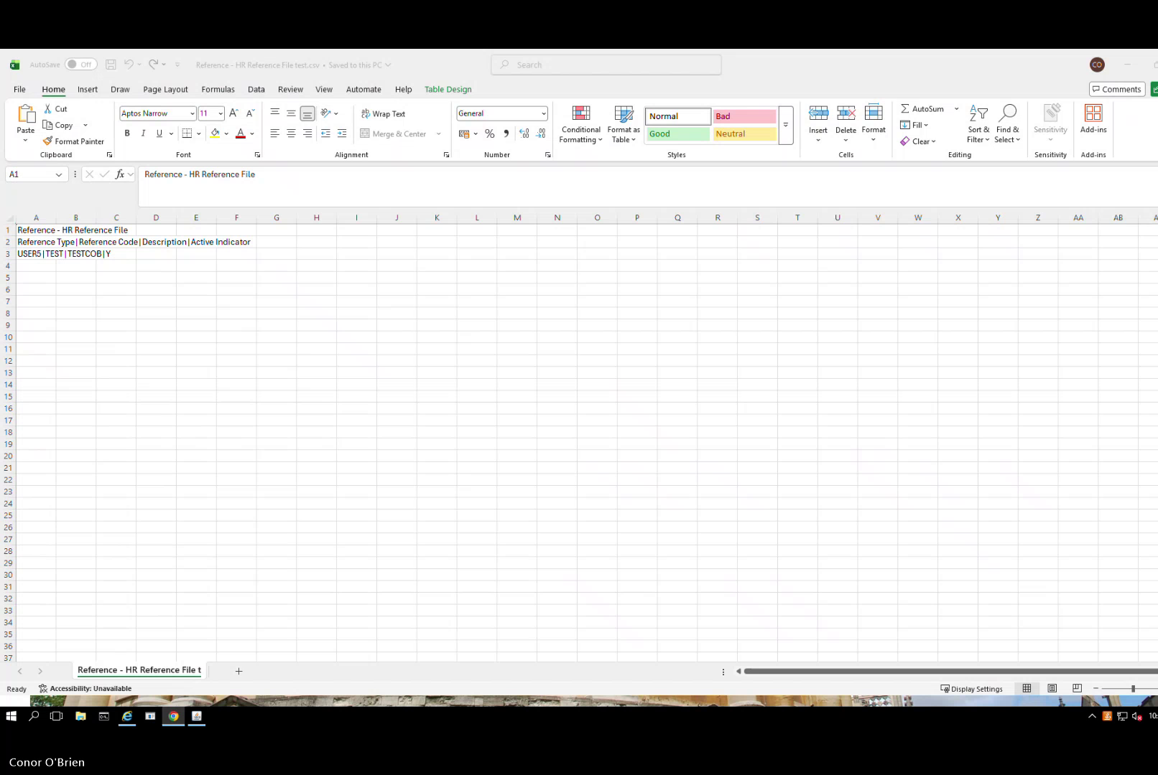
HR Reference File — blank template. Four columns required: Reference Type | Reference Code | Description | Active Indicator
- Prepare your file in pipe-delimited format with these four columns: Reference Type | Reference Code | Description | Active Indicator
- Reference Type must be: USER5 (this is the code for Pay Administered By — must be exact)
- Populate all 40 college codes (see table below)
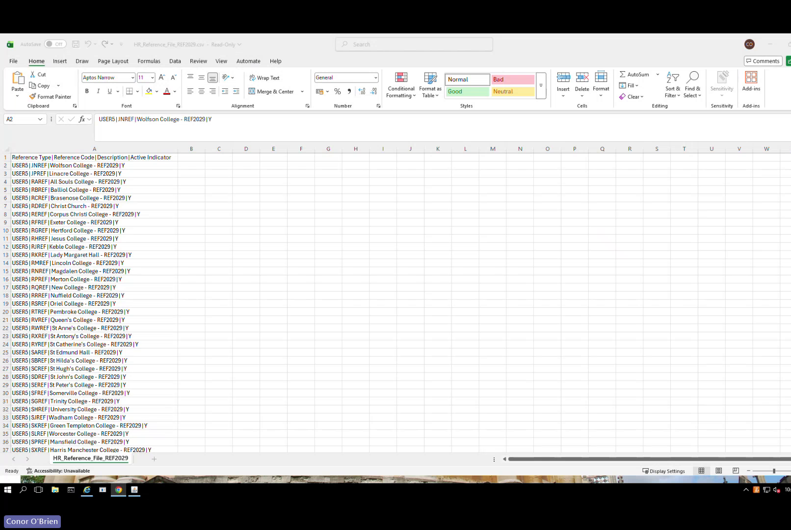
Populated upload file — all 40 college codes entered in pipe-delimited format with USER5 reference type and REF2029 suffix in description
Header row warning: Keep the header row at the top of the file. PeopleXD recently changed to require this — removing the header causes the load to fail.
Hyphen warning: If the upload fails with an invalid character error, re-type all hyphens manually (do not paste). Pasted hyphens from some sources are rejected.
- Upload via Data Migration tool → select Process All Records
- Verify all 40 entries appear as Active in User Code 5 reference data
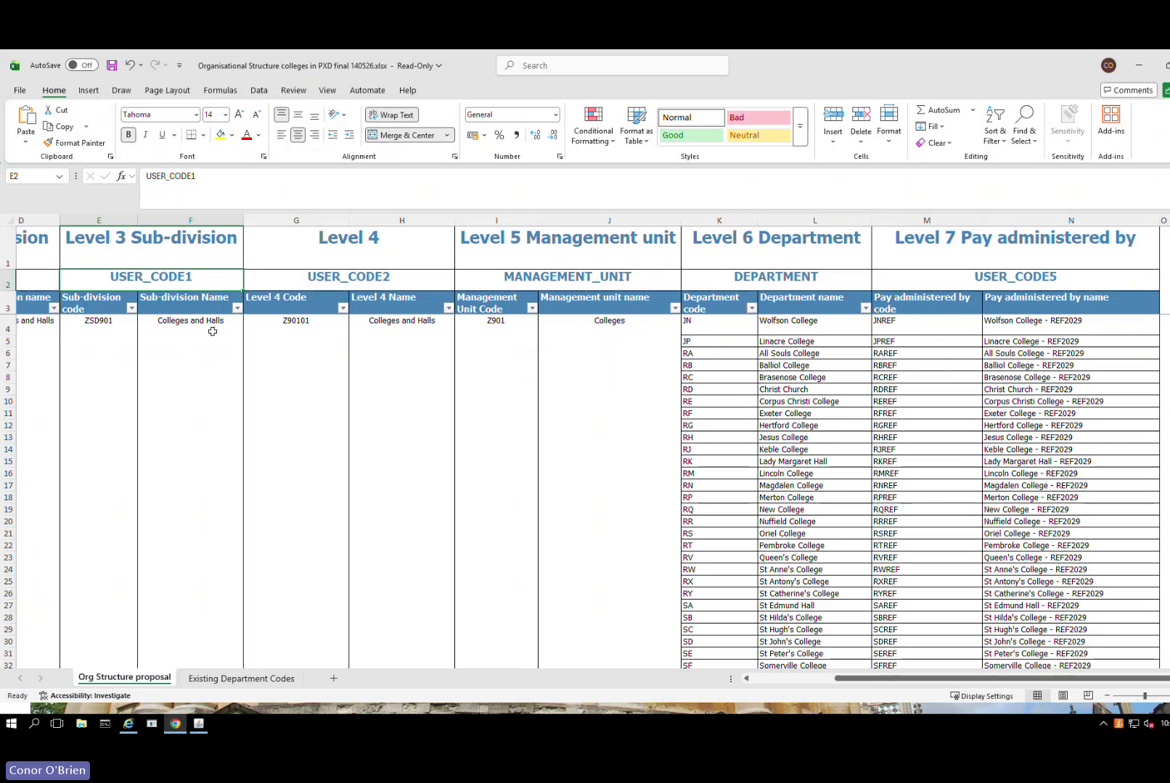
Completed hierarchy mapping showing departments linked to Pay Administered By codes — this is the target state after completing Steps 6 and 7B
Full Pay Administered By code list — 40 entries (Reference Type: USER5):
Code | College / Hall
JNREF | Wolfson College
LNACRE | Linacre College
RAREF | All Souls College
RBREF | Balliol College
RCREF | Brasenose College
RDREF | Christ Church
REREF | Corpus Christi College
RFREF | Exeter College
RGREF | Hertford College
RHREF | Jesus College
RJREF | Keble College
RKREF | Lady Margaret Hall
RMREF | Lincoln College
RNREF | Magdalen College
RPREF | Merton College
RQREF | New College
RRREF | Nuffield College
RSREF | Oriel College
RTREF | Pembroke College
RVREF | Queen's College
RWREF | St Anne's College
RXREF | St Antony's College
RYREF | St Catherine's College
SAREF | St Edmund Hall
SBREF | St Hilda's College
SCREF | St Hugh's College
SDREF | St John's College
SEREF | St Peter's College
SFREF | Somerville College
SGREF | Trinity College
SHREF | University College
SIREF | Wadham College
SKREF | Green Templeton College
SLREF | Worcester College
SPREF | Mansfield College
SXREF | Harris Manchester College
SMREF | Campion Hall
SQREF | Regent's Park College
SVREF | Wycliffe Hall
SYREF | Blackfriars

Step 7 — Link the Hierarchy in Structure Setup
Navigation: People Management → View All → Structure Setup → University of Oxford Structure

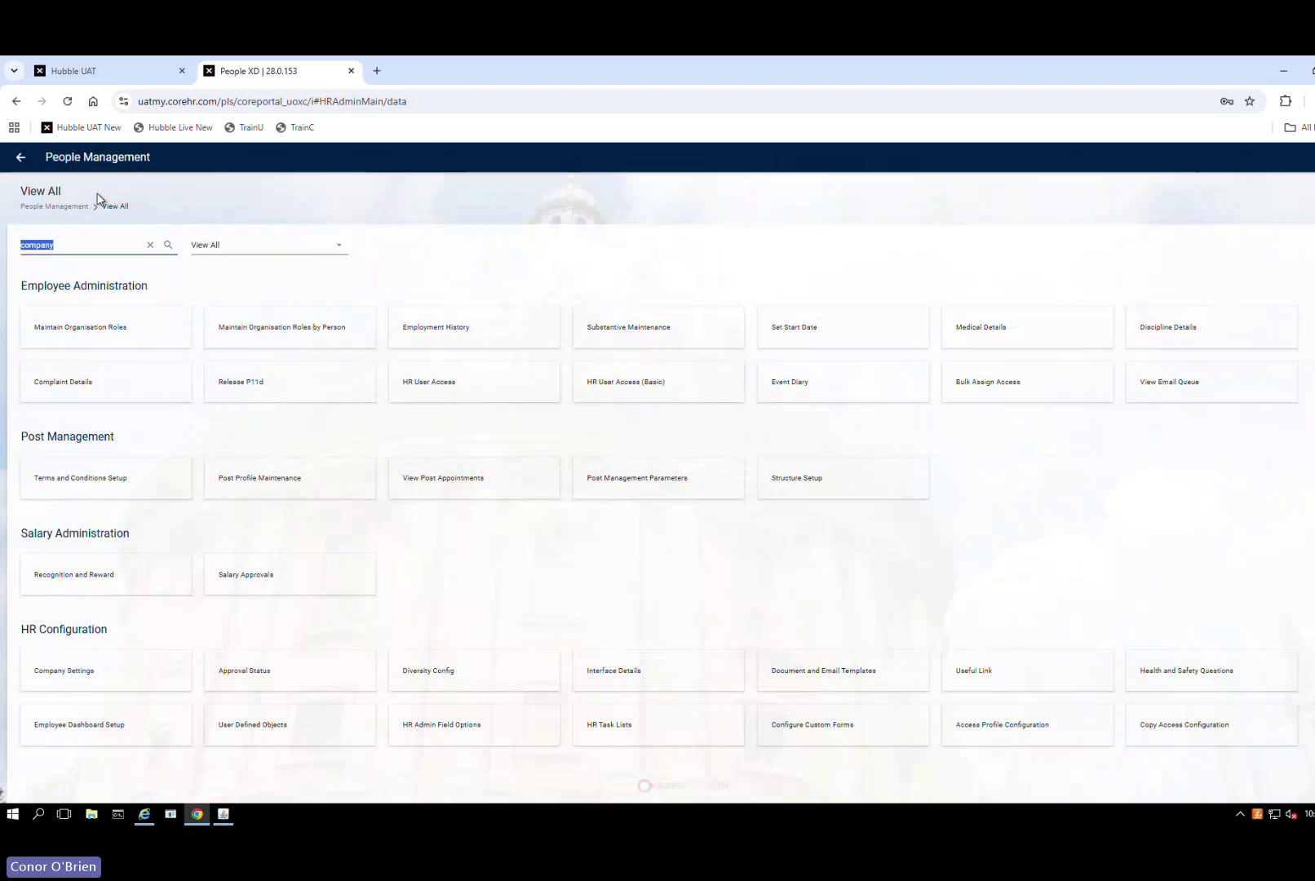
People Management → View All — navigate to Structure Setup from this screen
Critical: Always use Portal for hierarchy linking — not Back Office. Back Office causes sync issues where relationships do not appear correctly.
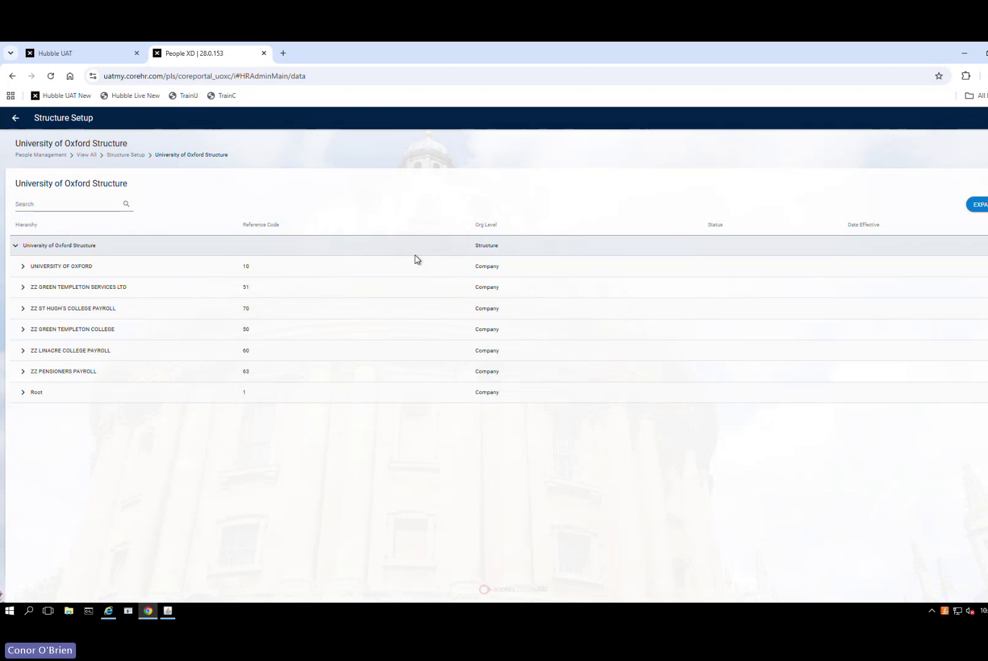
University of Oxford Structure — Company 90 should appear here once created. Open it to start linking the hierarchy levels.
- Locate Company 90 in the University of Oxford Structure
- Link in order: Division (901) → Subdivision (ZSD901) → Level 4 (Z90101) → Management Units (Z901 and Z902)
- Save after each addition
Screenshot pending: Completed hierarchy with Company 90 fully linked through to Management Units — capture during live UOXU configuration
✓ Validate: Company 90 visible · Division 901 → Subdivision ZSD901 → Level 4 Z90101 → Management Units Z901 and Z902 all linked

Step 7B — Link Pay Administered By to Each Department
This is the final and most important step. For each college department under each management unit, you must manually link its Pay Administered By code. Without this link the salary tab will not work correctly for staff in that college.
Navigation: People Management → View All → Structure Setup → University of Oxford Structure

For each department under Z901 (Colleges & Halls) and Z902 (Permanent Private Halls):
- Expand Company 90 → Division 901 → Subdivision ZSD901 → Level 4 Z90101 → Management Unit (Z901 or Z902)
- Locate the college/department
- Click Add at department level
- Select the Pay Administered By code for that college from the table below (e.g. All Souls College = RAREF)
- Click Add to hierarchy
- Save
- Repeat for every department under both Z901 and Z902
Critical — do not delete at a high level: Deleting a Division, Subdivision or Level 4 entry wipes everything linked beneath it and requires a full rebuild. Only delete at Pay Administered By level — that only removes the link, not the reference data.
Note: Conor demonstrated this step on the 12 June call and completed some entries. Check Structure Setup first to see which departments already have Pay Administered By linked before starting, to avoid duplicating work.
Screenshot pending: Structure Setup — Pay Administered By being linked to a department (e.g. All Souls College → RAREF) — capture during live UOXU configuration
Screenshot pending: Completed hierarchy showing all departments with Pay Administered By linked — capture when complete
✓ Validate: Every department under Z901 and Z902 has a Pay Administered By code linked · Salary tab visible on a test staff record · Hierarchy fully built

Final Checklist

Company
- ☐ Company 90 created — Code 90 · Name: Non Payroll COLLEGES AND HALLS · Contact: REF2029
- ☐ Company 90 added to Data Centre → Company Settings
- ☐ HR access to Company 90 granted to relevant users

Pay Group
- ☐ Pay Group 90 created — ZZ Do Not Use College Non-Pay
- ☐ Pay Group 90 linked to Company 90
- ☐ Pay Group 90 access granted to all relevant users

Hierarchy Reference Data
- ☐ Division 901 created (Staff Requests: inactive)
- ☐ Subdivision ZSD901 created and active
- ☐ Level 4 Z90101 created and active
- ☐ Management Unit Z901 (Colleges & Halls) created and active
- ☐ Management Unit Z902 (Permanent Private Halls) created and active

Pay Administered By
- ☐ All 40 college codes loaded via Data Migration (Reference Type: USER5)
- ☐ Header row retained in upload file
- ☐ All 40 entries active — verified via User Code 5 filter

Hierarchy Linking
- ☐ All hierarchy levels linked in Portal (not Back Office)
- ☐ Pay Administered By code linked to every department under Z901 and Z902

Testing
- ☐ Hierarchy visible in Portal
- ☐ New post can be created under Company 90
- ☐ Salary tab visible and correctly controlled by Pay Group 90 access
- ☐ Reporting structure correct

Support
Need | Contact
System issues, bugs, configuration problems | The Access Group — support via PXD Portal
Raising a formal change request | PeopleXD (change request process only)

